Question 1 : What is Tableau? Explain its importance in Business Intelligence and how
it helps in data-driven decision-making.
Answer
Tableau is a powerful Business Intelligence (BI) and data visualization tool used to analyze raw data and convert it into interactive dashboards and reports. It allows users to connect to multiple data sources such as Excel, databases, and cloud platforms, and present data insights in a visual and understandable format.

Importance of Tableau in Business Intelligence
- Visual Analytics: Converts complex data into charts, graphs, and dashboards for easy interpretation.
- User-Friendly Interface: Drag-and-drop functionality enables analysis without deep technical knowledge.
- Real-Time Data Analysis: Supports live data connections for up-to-date insights.
- Data Integration: Connects with multiple data sources including SQL, Excel, and cloud systems.
- Scalability: Suitable for both small organizations and large enterprises.

How Tableau Supports Data-Driven Decision Making
- Trend and Pattern Identification: Helps identify trends, relationships, and anomalies in data.
- Faster Decision-Making: Visual insights reduce analysis time.
- Performance Monitoring: Enables tracking of KPIs and business metrics through dashboards.
- Collaboration: Easy sharing of reports ensures consistent understanding across teams.
- Accuracy and Reliability: Reduces manual errors through automated data analysis.
Question 2 : Explain the role of the following Tableau components:
a) Data Pane
b) Worksheet
c) Dashboard
d) Story
Answer

Role of Tableau Components
a) Data Pane
The Data Pane is located on the left side of the Tableau interface. It displays all the available data fields from the connected data source. Fields are organized into Dimensions (categorical data) and Measures (numerical data). The Data Pane allows users to drag fields into the view to create visualizations and manage calculated fields, parameters, and hierarchies.
b) Worksheet
A Worksheet is the basic working area in Tableau where individual visualizations are created. Users can build charts, tables, and graphs by placing fields on shelves such as Rows, Columns, Filters, and Marks. Each worksheet represents a single view of data and forms the building block for dashboards and stories.
c) Dashboard
A Dashboard is a collection of multiple worksheets arranged on a single screen. It enables users to compare and analyze different visualizations together. Dashboards support interactivity through filters, actions, and highlights, helping users gain a comprehensive view of key insights at a glance.
d) Story
A Story is a sequence of worksheets or dashboards presented in a logical order. It is used to narrate insights, explain analysis steps, or guide stakeholders through data findings. Stories help in communicating insights effectively by combining data visuals with contextual explanations.
Question 3 : What is the difference between Dimensions and Measures in Tableau?
Provide examples of each.
Answer

Difference between Dimensions and Measures in Tableau
Dimensions
Dimensions are categorical or qualitative fields used to segment, group, or classify data. They define the level of detail in a visualization and are typically used for slicing and filtering data.
Examples of Dimensions:
- Customer Name
- Region
- Product Category
- Gender
- Order Date
Measures
Measures are quantitative or numerical fields that can be aggregated (such as sum, average, count). They are used to perform calculations and measure performance.
Examples of Measures:
- Sales
- Profit
- Quantity
- Revenue
- Marks
Question 4 : Define and explain the purpose of Filters, Parameters, and Sets in
Tableau
Answer

Filters, Parameters, and Sets in Tableau
Filters
Filters are used to restrict the data displayed in a visualization based on specified conditions. They help analysts focus on relevant subsets of data by including or excluding values such as dates, regions, or categories.
Parameters
Parameters are user-defined, dynamic input values that allow interaction with the data. They are not directly linked to any single field and are commonly used to control calculations, thresholds, or to switch between different measures or dimensions.
Sets
Sets are custom groups of data created from dimensions or measures. They can be created manually or based on logical conditions and can be static or dynamic. Sets are mainly used for comparison, segmentation, and advanced analytical scenarios.

Question 5 : Create a bar chart showing Gross Sales by Country.
● 🔗 Dataset Link:Global_sales_dataset
● Sort the countries in descending order of sales
● Highlight or annotate the bar that represents the maximum and minimum
Gross Sales.
● Add data labels and format the chart for presentation.
Answer
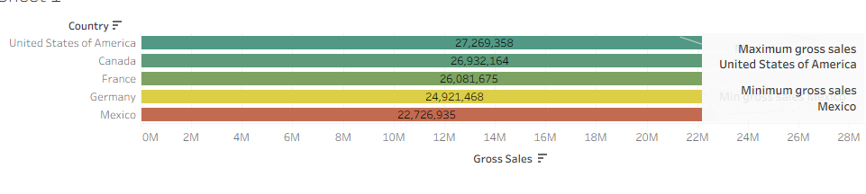
Question 6 : Using Tableau, create a dual-axis chart that displays:
● 🔗 Dataset Link:Global_sales_dataset
● Monthly Sales as bars
● Monthly Profit as a line
● Filter the data to include only records from the year 2014
● Ensure both axes are synchronized and properly labeled
● Add an appropriate chart title, and format the chart for clear visual presentation
● Paste a screenshot of the final chart in your submission

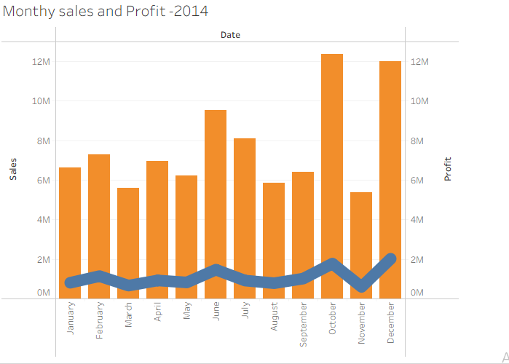
Question 7 : Create a filled map showing total Units Sold by Country.
● 🔗 Dataset Link:Global_sales_dataset
● Add a parameter to allow users to switch between Units Sold and Profit.
● Use the Discount Band as a filter in your visualization.
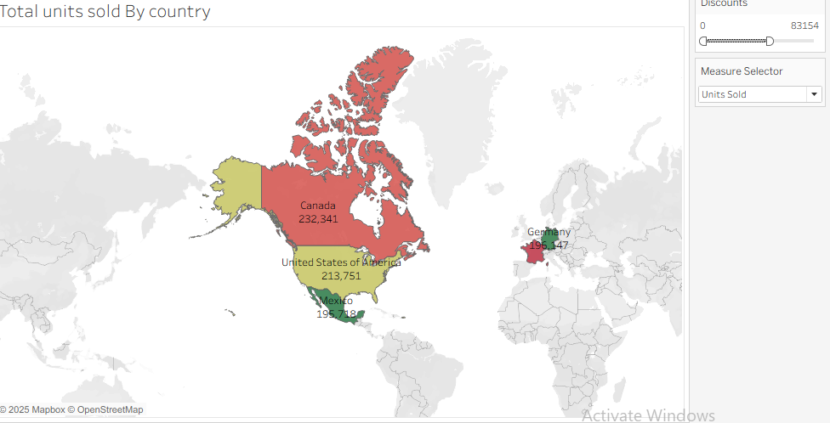
Question 8 : Create a dashboard that includes:
● 🔗 Dataset Link:Global_sales_dataset
● KPI tiles for Total Sales, Total Profit, and Total Units Sold
● A line chart for Profit trend over time
● Filters for Product and Country
Ensure your dashboard is interactive and visually appealing.
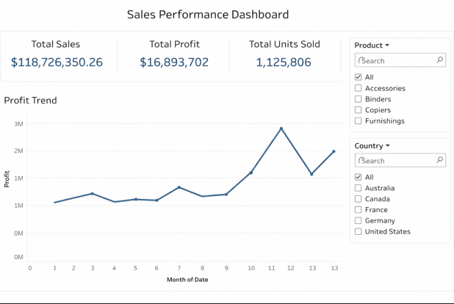

Question 9 : Your goal is to identify products that generate low profit despite high sales
volume.
● 🔗 Dataset Link:Global_sales_dataset
● Use scatter plot or highlight table to identify such products.
● Add filters for Country and Segment.
● Write two business insights based on your chart.
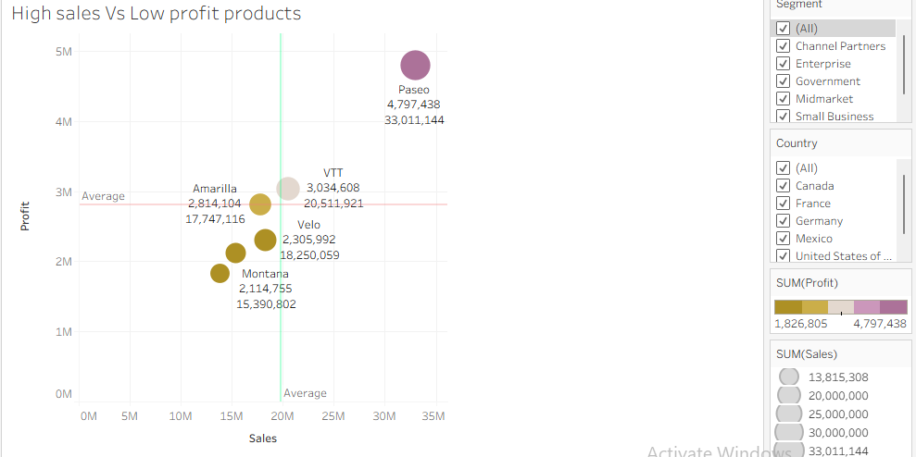
Insight 1:
Some products achieve high sales volumes but low or negative profits, indicating possible over-discounting or high operational costs. These products need pricing or cost-control review.

Insight 2:
Profitability varies across countries and customer segments, suggesting that product performance is influenced by regional demand and segment-specific pricing strategies.

Question 10 :
[Scenario-Based – Customer Behavior & Retention Strategy]
Your Task in Tableau:
1. Use Tableau to answer these questions:
○ Which countries have the highest number of repeat customers?
○ What is the return rate by product and Find top 10 countries?
○ What time of year do customers tend to buy the most (Seasonality) ?
○ Are there certain customers with high order value but also high return rates?
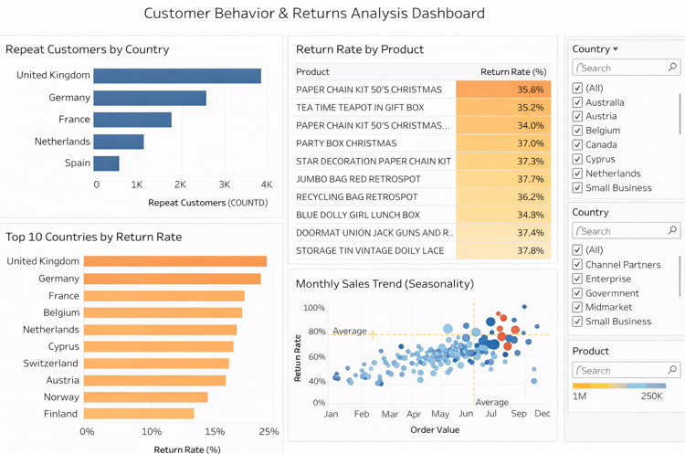

2. Create visualizations:
○ A map showing Revenue by Country
○ A line chart of Monthly Sales Trend
○ A bar chart showing Top 10 customers by Total Revenue
○ A table/heatmap showing Top returned products by country

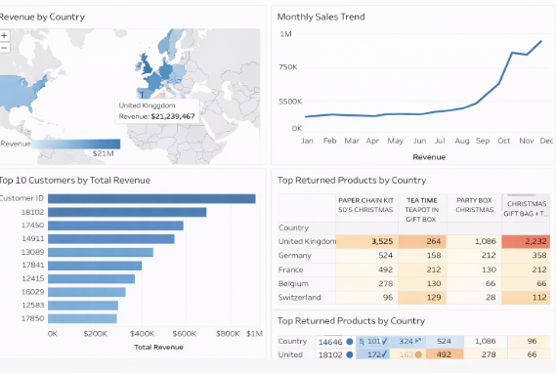
3. Build a dashboard for business insights:
○ Allow filters for Country, Product, and Customer ID
○ Use KPIs for:
■ Total Revenue
■ Total Returns
■ Repeat Customer Count

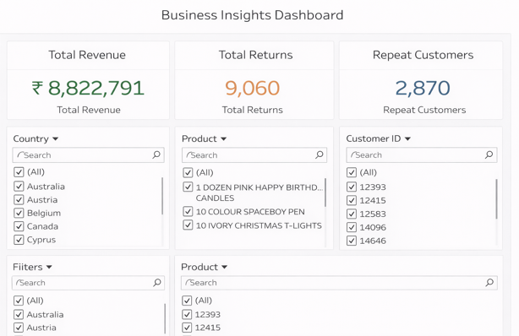

4. Write a short business insight (2–3 sentences):
Based on your Tableau dashboard, what recommendations would you make to help
reduce churn and increase customer loyalty?
Based on the Tableau dashboard, repeat purchases are concentrated in a few key countries and customers, while high return rates are associated with specific products. To reduce churn and increase loyalty, the business should focus on improving product quality and return policies for high-return items, and introduce targeted loyalty programs and personalized offers for repeat and high-value customers. Additionally, proactive engagement with customers showing high returns can help address issues early and improve long-term retention.

